FITFLEX
AP23110010354
AP23110010378
AP23110010385
AP23110010411

Welcome to the future of fitness evolution—where innovation meets motivation. FitFlex is not just another fitness platform; it is a transformative experience engineered to elevate your workout journey through precision, personalization, and powerful technology.
Designed for the modern fitness enthusiast, FitFlex seamlessly blends dynamic workout intelligence with an elegant, user-centric interface. Whether you’re sculpting your first routine or mastering advanced fitness regimens, FitFlex empowers you with a training experience tailored to your goals, pace, and lifestyle.
At the heart of FitFlex lies a smart, adaptive system built to understand your body and optimize your performance. Dive into an immersive fitness environment where every rep, every calorie burned, and every milestone achieved is tracked, analyzed, and celebrated. From interactive workout plans to real-time progress insights, FitFlex turns your fitness aspirations into an inspiring daily reality.
Accessible across all devices—mobile, tablet, or desktop—FitFlex delivers a responsive, engaging, and motivating platform wherever you go. Say goodbye to outdated routines and welcome a new era of intelligent fitness guidance.
Step into the FitFlex revolution. Redefine the way you train, transform the way you move, and unlock your strongest self. Your fitness journey begins here—it’s time to flex your future.
- Target Audience:-
- FitFlex is tailored for a broad range of users who want to track, improve, and maintain their fitness lifestyle, including:
- Fitness Enthusiasts:
- Individuals passionate about health and exercise who want to monitor their daily activities, workouts, and progress.
- Beginners in Fitness:
- People starting their fitness journey and looking for a simple platform to log workouts, track steps, calories, and develop consistent habits.
- Goal-Oriented Individuals:
- Users who want to set fitness goals, monitor progress, and stay motivated through visual insights and activity tracking.
- Project Goals and Objectives:-
- The primary goal of FitFlex is to provide a smooth, engaging platform for users to manage and track their fitness routines effectively. The main objectives include:
- User-Friendly Interface:
- Design a clean, intuitive interface where users can easily log activities, view daily performance, and track their progress in a structured manner.
- Comprehensive Fitness Tracking:
- Offer powerful features that allow users to record exercises, monitor calories burned, track steps, and maintain a history of their workouts.
- Progress Visualization:
- Provide charts, summaries, and dashboards to help users understand their improvement over time.
- Modern Tech Stack:
- Use modern technologies like React.js, Axios, React Router, and JSON Server to deliver a fast, responsive, and enjoyable user experience.
- Key Features:-
- Activity Logging:
- Users can add daily fitness activities such as running, walking, cycling, strength training, etc., along with duration, calories, steps, and notes.
- Dashboard Overview:
- A visual dashboard showing total calories burned, total steps, number of workouts, and recently logged exercises.
- Editable Workout Entries:
- Users can view, edit, and delete any previously logged activities at any time.
- Fitness Goals Tracking:
- A dedicated goals section where users can set weekly or monthly goals for steps, calories, or workouts and monitor their progress.
- Responsive UI:
- Designed to work across different screen sizes—desktop, tablet, and mobile—for a seamless user experience.
- Lightweight Backend with JSON Server:
- Manages user activity data, goals, and profile information through simple REST APIs.

PRE-REQUISITES:-
Here are the essential prerequisites for developing a frontend application using React.js:

1. Node.js and npm
Node.js is a JavaScript runtime environment that allows you to run JavaScript outside the browser. It is required for package management, development tools, and running the React development server.
You must:
- Install Node.js and npm on your system.
- Ensure Node and npm versions are up-to-date.

2. React.js
React.js is a widely used JavaScript library for building user interfaces. It helps in creating reusable components and dynamic web pages.
To create a React application:
- Use the command:
npm create vite@latest
- Provide your project name and select your preferred framework.
- Navigate into your project folder.
cd project-name
- Install dependencies.
npm install
To start the development server:
- Run npm run dev
- The app will open on the local development server.

3. HTML, CSS, JavaScript
Basic knowledge of:
- HTML (structure of web pages)
- CSS (styling, layout, responsiveness)
- JavaScript (logic, interactivity)
These are necessary for designing and developing the user interface.

4. Version Control (Git)
Use Git for:
- Tracking changes
- Maintaining version history
- Collaborating with team members
Platforms like GitHub or Bitbucket can host your repository.
You must:
- Install Git on your system
- Use commands like git init, git add, git commit, git push

5. Development Environment
Choose a suitable code editor or IDE for writing code. Popular choices include:
- Visual Studio Code
- Sublime Text
- WebStorm
These tools provide syntax highlighting, extensions, debugging features, and a smooth development experience.

Project structure:
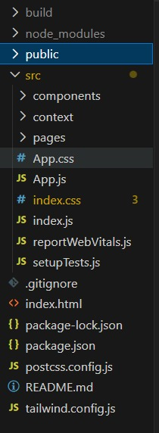

Project Structure
- The public folder contains static files and the main index.html which acts as the entry point for the React application, providing the base HTML structure.
- The src folder holds all the core source code, including components, pages, context, and global styles, making it the central workspace of the application.
- The components folder includes reusable UI elements that can be shared across multiple pages to ensure consistency and reduce code duplication.
- The pages folder contains the main screen-level components such as Dashboard, Activities, and Profile, which are loaded through React Router based on navigation.
- Root files like App.js, index.js, and configuration files (package.json, tailwind.config.js, postcss.config.js) manage app rendering, styling setup, dependencies, and development configurations.

Milestone 1: Project Setup and Configuration:
1. Install required tools and software:
- Installation of required tools:
- Open the project folder to install necessary tools
In this project, we use:
- React Js
- React Icons
- Material-ui
- React-codemirror2
- For further reference, use the following resources
- https://react.dev/learn/installation
- https://react-bootstrap-v4.netlify.app/getting-started/introduction/

Milestone 2: Web Development:
1. Setup React Application:
• Create React application.
• Configure Routing.
• Install required libraries.
App.js component.
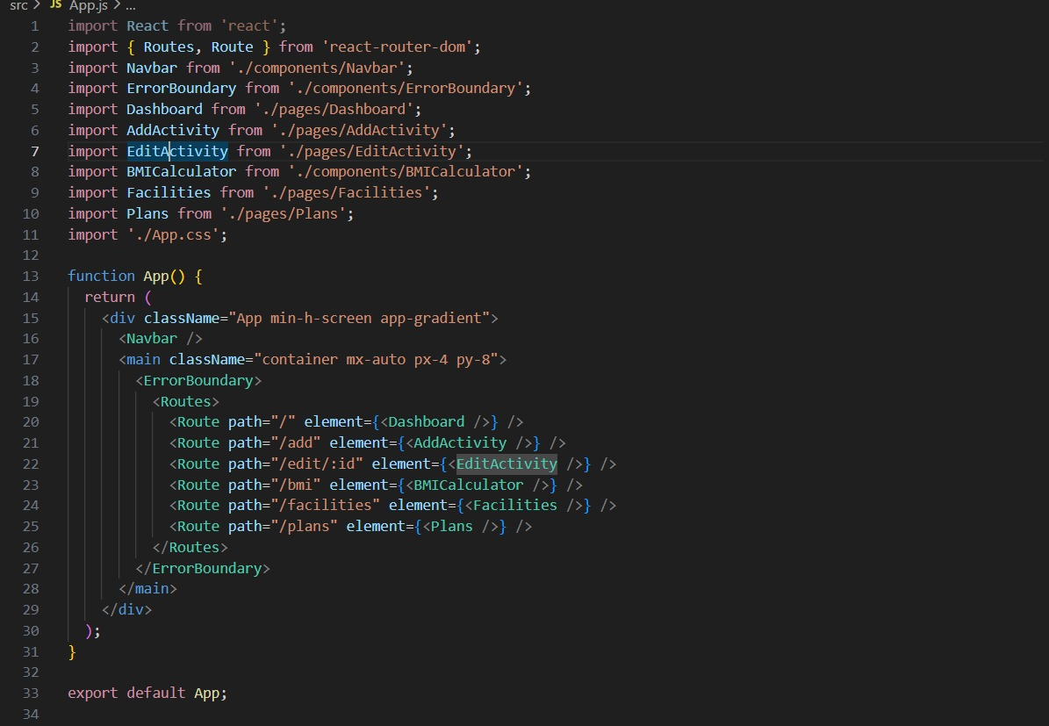

Code Description:-
- The App.js file serves as the main entry component that controls the layout, navigation, and routing for the entire application.
- It imports key components such as Navbar, Dashboard, AddActivity, EditActivity, BMICalculator, Facilities, and Plans to render different pages.
- The Routes and Route elements from react-router-dom are used to map URL paths to specific components for seamless navigation.
- An ErrorBoundary wrapper is used to catch runtime errors and ensure the application continues running smoothly without crashing.
- The layout includes a global navigation bar and a main content container with defined styling for consistent UI across all pages.

- Design UI components:
- Create Components
- Implement Layout and Styling
- Add Navigation

3. Implement frontend logic:
• Integration with API endpoints.
• Implement data binding.
Data Provider:-
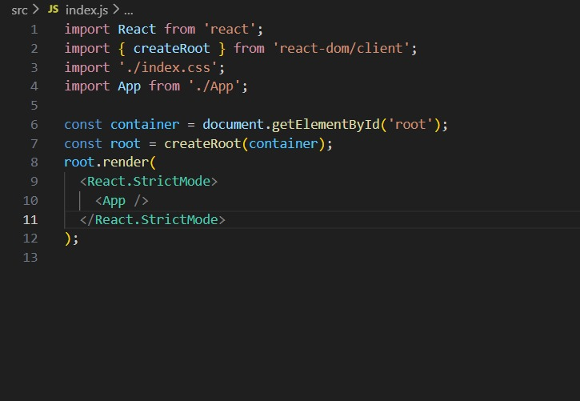
Code Description:-
Imports React and necessary modules
The file imports React, the createRoot function from react-dom/client, the global CSS file (index.css), and the main App component to be rendered.
Selects the root DOM element
The container variable gets the HTML element with the ID "root" where the entire React application will be mounted.
Creates a React root
createRoot(container) initializes the new React 18 rendering engine, enabling improved performance and concurrent features.
Renders the App component
The root.render() method mounts the <App /> component inside the root element, making the entire React application visible in the browser.
Uses React.StrictMode for debugging
Wrapping <App /> inside <React.StrictMode> activates additional checks and warnings during development to help identify potential issues.
Code Components:
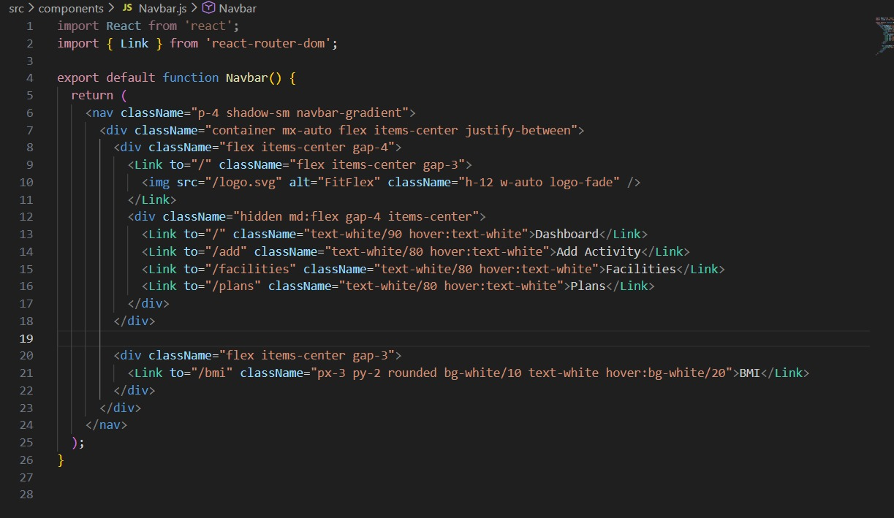
- Imports and Setup
The component imports React and the Link component from react-router-dom to enable navigation between different pages without reloading the application.
- Navigation Bar Structure
The <nav> element defines the top navigation bar, styled using utility classes (e.g., p-4, navbar-gradient, shadow-sm) to create a clean, responsive header.
- Logo Section
The left side of the navbar contains the application logo wrapped inside a Link tag. Clicking it returns the user to the homepage ("/" route).
- Page Navigation Links
A list of navigation links (Dashboard, Add Activity, Facilities, Plans) is displayed for medium and larger screens (md:flex). Each link is styled with hover effects using Tailwind classes.
- BMI Button Section
On the right side, a dedicated BMI Calculator button is provided, styled with padding, rounded corners, and hover effects, making it visually distinct from other links.
Code-Editor Component:-
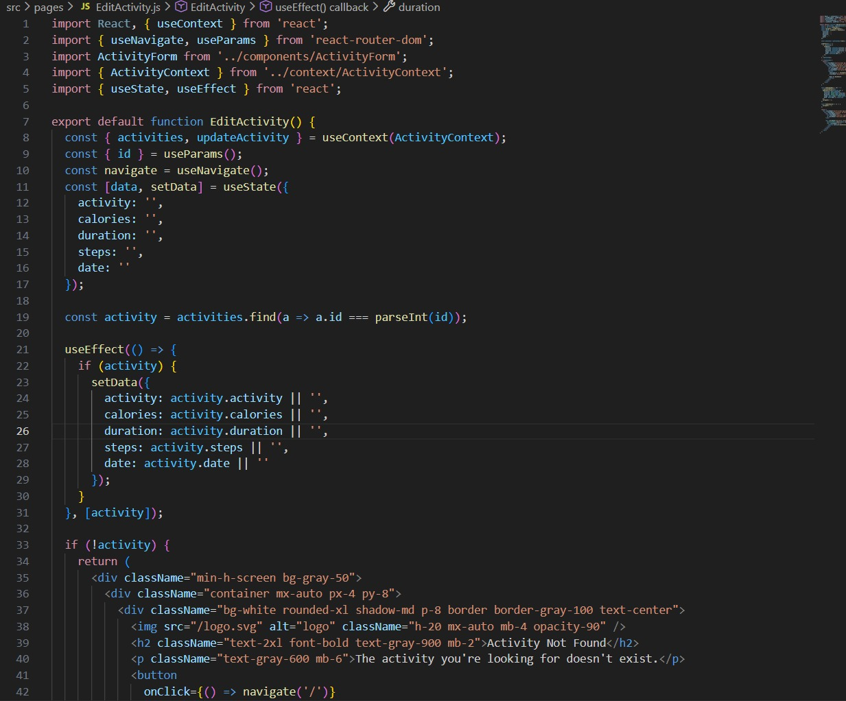
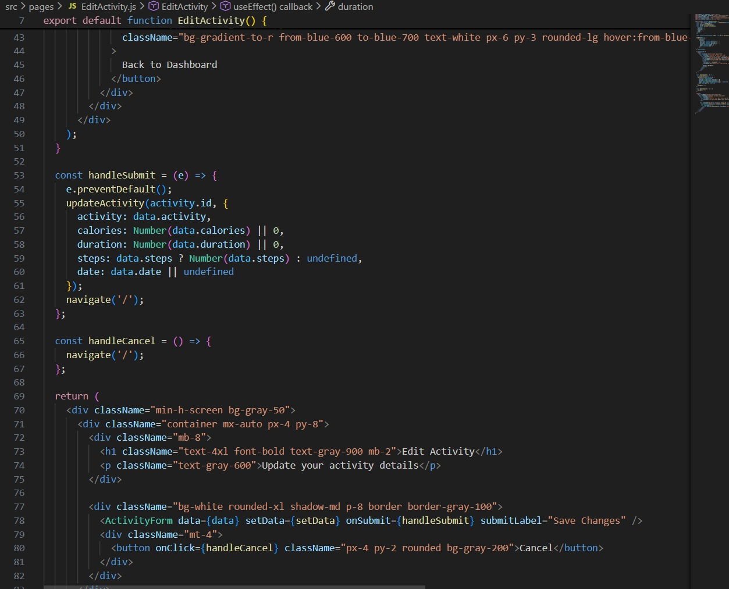
Imports React Hooks and Context
The component imports useContext, useState, useEffect, useParams, and useNavigate.
It also imports the ActivityContext to access and update the global activities data.
Extracts Activity ID from URL
Using useParams(), the component retrieves the id parameter from the route (/edit/:id), which identifies which activity needs to be updated.
Finds the Activity to Edit
The component searches the activities list and locates the activity matching the given ID using .find().
If no activity is found, a "Not Found" screen is displayed.
Initializes and Pre-Fills Form Data
A useState() object stores fields like activity, calories, duration, steps, and date.
Through useEffect(), the form is automatically populated with existing activity data when the component loads.
Handles Activity Not Found Case
If the activity does not exist (invalid ID), the component renders an error page with a message and a button to navigate back to the dashboard.
Handles Form Submission
The handleSubmit() function updates the activity using updateActivity() from the context.
All inputs are properly converted (e.g., numbers for calories and duration).
After updating, the user is navigated back to the dashboard.
Displays Editable Form and Actions
The UI renders the ActivityForm component pre-filled with existing data.
It includes:
- A Save Changes button (to submit the updated activity)
- A Cancel button (handled by handleCancel()), returning the user to the dashboard
Project Execution:
After completing the code, run the react application by using the command “npm start” or “npm run dev” if you are using vite.js
Here are some of the screenshots of the application.
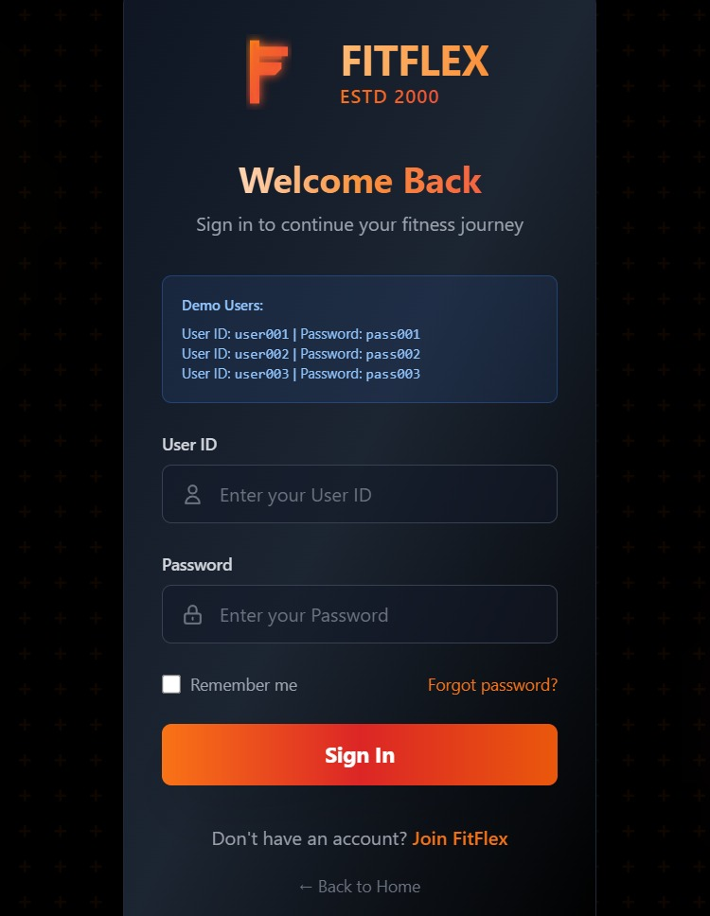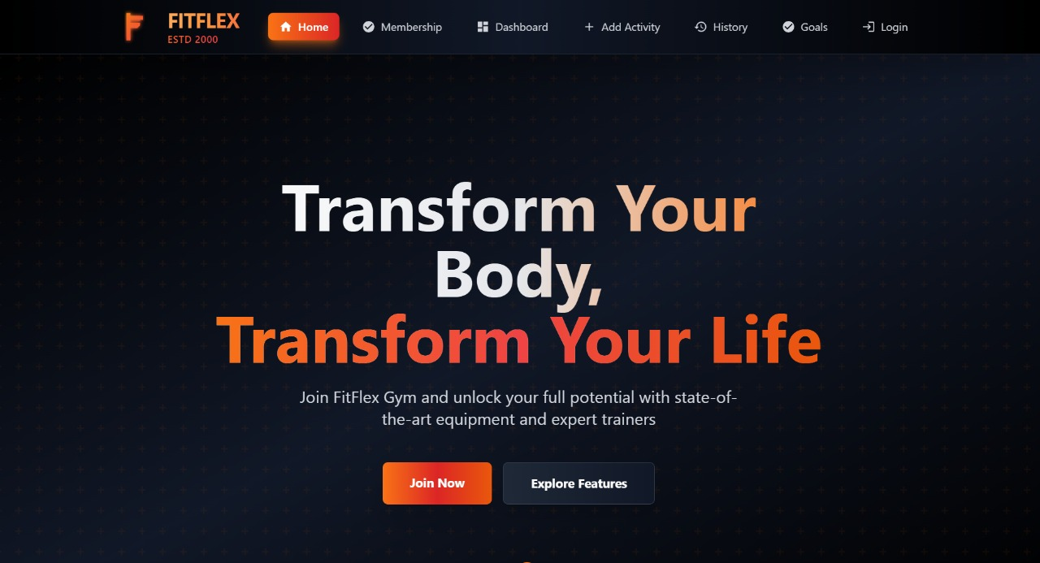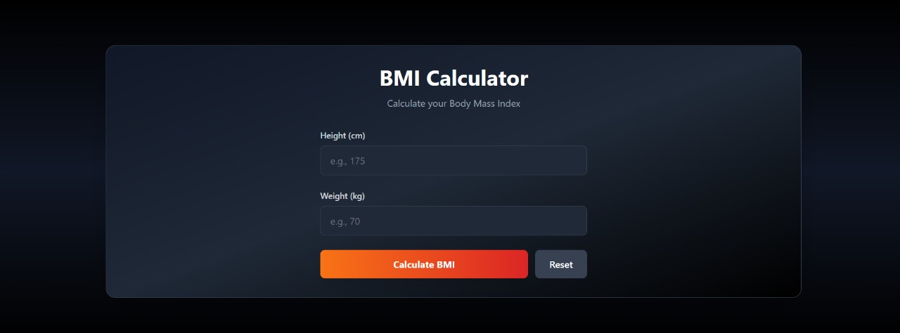

------THANK YOU------

